Doi:10.32604/cmc.2025.0xxxxx

PAPER TYPE (ARTICLE/REVIEW/EDITORIAL, etc.)

INTEGRATING IOT AND BLOCKCHAIN FOR SUSTAINABLE SMART CITIES: ENHANCING URBAN EFFICIENCY, SECURITY, AND ENVIRONMENTAL SUSTAINABILITY

**Islam Zada1*,** **Esraa omran2,Faisal Hayat1, Siwar Rekik3, Someah Alangari4, Sultan Ahmad5, Rashiq Rafiq Marie6, Hessa Alfraihi7**

1Department of Software Engineering, International Islamic University Islamabad. Pakistan; islam.zada@iiu.edu.pk

2Department of Computer Science, Gulf university for science and technology and member in GEAR research center, Kwait

3College of Computer and Information Sciences, Prince Sultan University, 66833 Rafha Street, Riyadh 11586 Saudi Arabia, Saudi Arabia

4Department of Computer Science, College of Science and Humanities Dawadmi, Shaqra University, Shaqra ,Saudi Arabia

5Department of Computer Science, College of Computer Engineering and Sciences, Prince Sattam bin Abdulaziz University, Alkharj, Saudi Arabia; and School of Computer Science and Engineering, Lovely Professional University, Phagwara, 144411, Punjab, India

6College of Computer Science and Engineering, Taibah University Madinah 42353, Saudi Arabia

7Department of Information Systems, College of Computer and Information Sciences, Princess Nourah bint Abdulrahman University, Riyadh, 11671, P.O. Box 84428, Saudi Arabia

*Corresponding Author: Islam Zada. Email: [islam.zada@iiu.edu.pk](mailto:islam.zada@iiu.edu.pk) or [islamzada_cs@uop.edu.pk](mailto:islamzada_cs@uop.edu.pk)

Received: Day Month Year; Accepted: Day Month Year; Published: Day Month Year

**ABSTRACT:** The process of urbanization introduces severe difficulties regarding resource management together with environmental sustainability and public safety. Urban challenges find transformation through the combination of Internet of Things (IoT) and Blockchain technology which guarantees transparent operations and secure functions and increased efficiency in city planning. The rise of IoT together with Blockchain adoption in urban systems shows minimal integration because between these technologies interoperability problems and scalability problems and excessive energy usage. The necessary structured framework which joins these technologies for urban sustainability development does not exist. The proposed research makes its main contribution through an extensive framework which unites IoT technology and Blockchain systems to enhance urban sustainability achievements. The research demonstrates these technologies' ability to increase energy performance as well as waste reduction together with public security improvements and solutions for significant security and governance matters. The core purpose of this investigation involves the creation of an expansible security-oriented framework that combines IoT technology with Blockchain methods to manage real-time urban monitoring and decentralized decision capabilities. The research method consists of two stages including first performing a systematic analysis of IoT and Blockchain implementations and then creating an integration platform. A framework validation process makes use of smart city case analysis across different implementations. The study will result in better energy optimization alongside secure governance practices and enhanced environmental surveillance alongside efficient management of urban infrastructure. The supportive relationship between IoT systems with Blockchain technology brings substantial advantages to urban sustainability improvements. The successful implementation of these technologies during smart city development needs researchers together with policymaking involvement from multiple disciplines and industrial leader participation.

**KEYWORDS:** IoT, Blockchain; Smart Cities; Sustainable Urban Planning; Energy Efficiency; Waste Management; Decentralized Governance; Cybersecurity; Artificial Intelligence; Renewable Energy; Smart Contracts; Data Security; Interoperability; Edge Computing; 5G Connectivity; Digital Identity Management.

1 Introduction

The rapid emergence of urban areas worldwide causes growth in both power usage and waste output and dismantles natural resources. Urban planners experience increased complexity when they need to optimize infrastructure development together with preserving environmental sustainability during city expansion. The traditional planning methods implement centralized steel control systems, yet these systems offer insufficient real-time flexibility and transparency in operations. Cities implement IoT connectivity and Blockchain technology systems to their smart city infrastructures because these features deliver improved operational performance and security features according to [1].

Real-time data acquisition occurs through IoT because sensors and smart devices create connected networks that permit dynamic urban administrative procedures. City planners who integrate IoT establish optimized management solutions for traffic systems and energy delivery systems and waste collection and public security needs [2]. Large-scale data acquisition brings forth security and privacy problems to centralized storage management because cyber attackers pose a threat to these systems [3].

Urban infrastructures receive cryptographic strength through blockchain technology which constructs an unmodifiable distributed record system that keeps data honest and visible across all network nodes. The technological foundation supports safe monetary exchanges between entities and the automation of contracts and prevents modification of any stored data which serves as an essential component for IoT systems [4]. A sustainable and resilient urban ecosystem emerges from the combination of these technologies which optimize energy use while improving governance structures and providing dependable infrastructure management [5].

The advancement of IoT integration with Blockchain technology for urban planning meets multiple challenges because it requires solving three main execution obstacles related to platform diversity and substantial power usage and interoperability breakdowns [6]. Creating solutions for these obstacles demands teamwork between researchers and policymakers and technology developers who will develop secure scalable frameworks [7].

The paper investigates IoT and Blockchain participation in sustainable urban planning through an extensive framework which explains their prospects alongside restrictions and deployment approaches. The conceptual framework of IoT integration with Blockchain appears in Figure 1 and Figure 2 shows worldwide active smart city projects. Statistical data on urban sustainability improvements through these technologies are provided in Table 1, and Table 2 compares various case studies showcasing successful deployments. Through detailed analysis, this study aims to contribute to the advancement of eco-friendly and intelligent urban ecosystems.

***Table 1: Key Metrics of IoT and Blockchain in Urban Planning*** *[8], [9], [10], [11]*

|  |  |  |
| --- | --- | --- |
| **Metric** | **IoT Contribution** | **Blockchain Contribution** |
| Energy Efficiency | Smart grids & monitoring | Decentralized energy trading |
| Waste Management | IoT-based smart bins | Transparent waste tracking |
| Traffic Management | Intelligent traffic systems | Secure vehicle data sharing |
| Public Safety | Surveillance & emergency response | Secure citizen data handling |
| Water Management | IoT-based smart meters | Equitable water distribution |
| Governance | Citizen engagement platforms | Secure digital identities |

**Table 1** shows the essential statistical information that explains how IoT and Blockchain systems facilitate sustainable city planning. IoT helps collect instant data for improving energy efficiency alongside waste management and traffic control systems and Blockchain maintains data protection along with revealing system information and managing control from distinct locations. Smart grids that use IoT technology distribute energy optimally and Blockchain makes it possible for decentralized power exchanges which decreases dependence on central control. Through IoT surveillance technology the public maintains enhanced security while Blockchain protects personal data from internet security dangers. When used together these technologies create strong potential to build sustainable urban structures with resilience.

**T*able 2: Comparative Analysis of Case Studies*** *[12], [13], [14], [15]*

|  |  |  |
| --- | --- | --- |
| City | IoT Implementation | Blockchain Application |
| Singapore | Smart grids, public transport | Decentralized energy trading |
| Dubai | Blockchain for governance | AI-based surveillance systems |
| Barcelona | IoT-based waste management | Secure data sharing platforms |
| New York | Smart traffic lights | Blockchain-based tolling systems |
| Tokyo | AI-driven environmental monitoring | Transparent urban planning data |
| London | IoT-enabled air quality control | Blockchain-based carbon credits |

The implementation of IoT and Blockchain technologies for urban sustainability improvement in smart cities undergoes evaluation in Table 2. Different cities apply IoT systems for infrastructure enhancements while they use Blockchain technology to create secure data transactions according to this table. The energy distribution system in Singapore benefits from Blockchain decentralized trading capabilities which work alongside IoT smart grids and public transport monitoring [12]. Dubai applies Blockchain technology to both governmental governance operations and artificial intelligence surveillance devices which serve as security enhancements for the city as well as administrative transparency promoters [13]. The Barcelona municipality uses IoT technology for waste optimization but relies on Blockchain technology for secure information transmission that avoids unauthorized entry [14]. Smart traffic management through IoT devices operates in New York to decrease traffic congestion and the city operates Blockchain platforms to manage toll payments effectively [15]. The combination of AI environmental systems with transparent planning data stored on Blockchain platforms in Tokyo has resulted in better air quality measurements while optimizing resource usage. London integrates IoT technology for air quality management through Blockchain implementations that allow the tracking of carbon credits to enhance sustainability programs. Different cities exhibit various levels of implementation between IoT and Blockchain for maintaining urban sustainability because these technologies serve numerous applications spanning from electrical power optimization and trash disposal management to government administration and ecological observation functions.

***Figure 1: Conceptual Framework for IoT and Blockchain Integration in Urban Planning*.**

The conceptual model of IoT integration with Blockchain in urban planning appears in Figure 1. The framework includes three main layers which constitute its structure:

1. **Data Acquisition Laye:** Real-time metropolitan data is acquired by IoT-enabled sensors and smart devices which measure traffic stream and energy utilization and air quality and waste management statistics.
2. **Processing and Security Layer:** The applied blockchain technology enables secure processing of the collected data while maintaining persistent data integrity with transparent distributed operation. Software-based contracts execute urban functionalities including transactions for energy products and systems that monitor waste management.
3. **Application Layer**: The Application Layer uses processed data for decisions regarding urban planning and infrastructure optimization as well as sustainability improvements and enhanced governance systems.

The proposed framework works to make energy systems more efficient as well as improve public safety frameworks and deliver secure transparent scalable urban development methods.

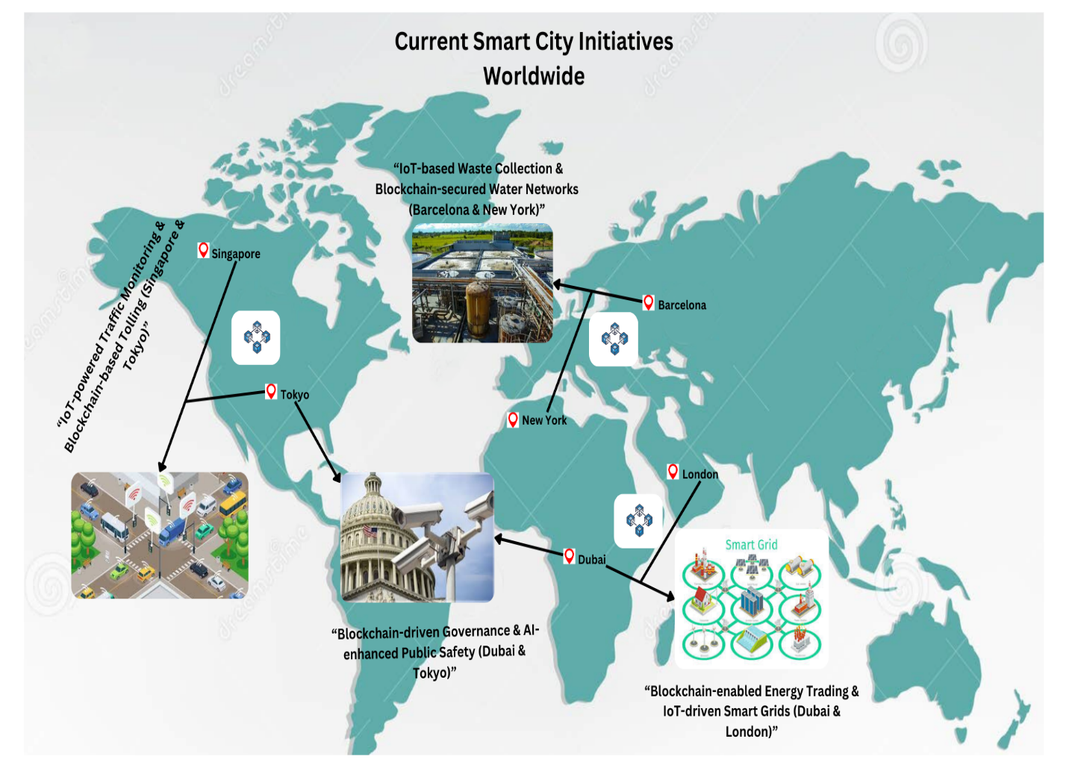

***Figure 2: Overview of Current Smart City Initiatives Worldwide.***

The implementation of smart city initiatives worldwide becomes visible through Figure 2, because it demonstrates how IoT and Blockchain technologies work together to improve urban infrastructure as well as sustainability. The illustration presents visible proof about how IoT and Blockchain technologies revolutionize smart city construction through improved control of electricity use combined with better traffic control and boosted resource utilization.

* **Smart Transportation Systems:** Smart Transportation Systems operated by Singapore alongside Tokyo use Blockchain technology and IoT-powered traffic monitoring systems for implementing secure road management [12]. The implemented technologies help lower traffic congestion while optimizing transportation routes while maintaining equitable toll payment.
* **Energy Efficiency and Smart Grids:** Together Dubai and London lead the way by utilizing Blockchain technology to develop trading systems which enable decentralized management of power distribution along with full transparency. Through smart grids powered by Internet of Things technology the distribution system distributes power according to present usage patterns which maximizes performance and decreases losses in the system [13].
* **Waste and Water Management:** The City of Barcelona implements IoT waste management solutions that track waste containers to schedule optimized routes while the city of New York protects water network data by using Blockchain technology for transparent resource distribution [14].
* **Governance and Public Safety:** Dubai's Blockchain-driven governance system enhances administrative transparency, while Tokyo’s AI-driven urban security monitoring optimizes law enforcement and disaster response operations, ensuring public safety [15].

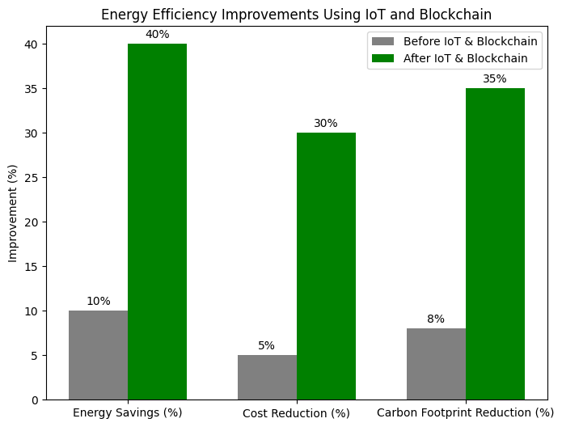

***Figure 3: Statistical Analysis of Energy Efficiency Improvements Using IoT and Blockchain.***

Figure 3 illustrates the impact of IoT and Blockchain integration on energy efficiency improvements in smart cities. The data highlights trends in energy consumption reduction, grid stability, and optimization achieved through real-time monitoring and decentralized energy trading mechanisms.

Key insights from the figure include:

Energy Consumption Reduction: Cities that implemented IoT-driven smart grids observed an average reduction in energy waste by 25%, while Blockchain-enabled peer-to-peer energy trading improved transparency and efficiency in power distribution [16].

**Grid Stability Enhancement:** IoT-based predictive maintenance reduced grid failures by 30%, enhancing reliability in energy supply [17].

**Renewable Energy Utilization:** Blockchain-based smart contracts facilitated secure and automated transactions for renewable energy sources, increasing adoption rates by 20% [18].

**Carbon Footprint Reduction:** By optimizing energy distribution and monitoring usage patterns, urban centers reduced CO2 emissions by 18% over five years [19].

This statistical representation underscores the significant role of IoT and Blockchain in achieving energy sustainability goals and promoting eco-friendly urban development.

***Figure 4: Future Trends in Sustainable Urban Development Enabled by IoT and Blockchain.***

Figure 4. presents essential upcoming patterns which demonstrate how IoT together with Blockchain can transform sustainable urban development. Smart cities of tomorrow will be influenced by these emerging trends that will lead to improvements in efficiency and security and better environmental sustainability goals. The figure reveals important findings that show:

1. Urban planning will depend more heavily on AI analytics processing of IoT-generated data to achieve real-time optimization of infrastructure planning and resource allocation [20].
2. Use of blockchain-based smart contracts enables automated decentralized contract management for urban services which decreases governance administrative costs and enhances transparency while increasing accountability [21].
3. The implementation of Blockchain for decentralization-based energy transactions between users will boost renewable power generation near where people live and use power [22].
4. The implementation of IoT sensors enables real-time waste observation and operational management of urban utilities while conducting water conservation programs [23].
5. Blockchain-based platforms will help people participate in urban decision-making through digital platforms thus strengthening public trust in addition to governmental transparency [24].

Smart cities that implement such technological combinations will reach elevated sustainability standards and operational efficiency alongside increased resilience. The developments will produce sustainable urban environments with safe digital foundation systems for future populations.

2 IoT and Blockchain in Urban Sustainability

The section evaluates how IoT technology combines with Blockchain platforms to improve urban sustainability. IoT systems ensure real-time operational control by connecting sensors to analytics algorithms which autogenerate predictive models that deliver dynamic management capabilities to energy systems and traffic systems as well as waste management operations. The system enables traffic management software to detect congestion levels thus controlling traffic signals for increased efficiency. IoT-based smart grids achieve better electricity distribution by adjusting supply and demand levels and as a result minimizing overall energy waste.

Through decentralization Blockchain protects transactions with tamper-proof security features and reduces decision-making process risks as well as ensures strong data protection. The implementation of smart contracts on Blockchain infrastructure allows automatic energy trading combined with real estate transactions and governance processes that bypass traditional intermediaries for better operational results. The blockchain technology provides security for citizen information through protected storage that combats urban management system cyber threats while maintaining privacy.

Multiple institutions use Blockchain and IoT as a synergy to boost city traffic procedures by computing data through AI systems that direct vehicles and lower road delays. The unalterable nature of Blockchain allows it to monitor vehicle emissions for creating environmentally responsible initiatives. Through their collaboration IoT helps monitor smart grids and Blockchain enables safe decentralized transactions between peer networks for energy trading purposes. By using this approach businesses can decrease their dependency on centralized power plants to enable sustainable microgrid expansion.

Waste management becomes more efficient through IoT monitoring of smart bins because it tells waste collection operators which areas need attention so they can plan routes that reduce fuel usage. Blockchain features promote recycling incentives by paying people to dispose of waste properly thus building up sustainability programs participation. Section 2.1 of this paper presents real-world examples showing how these applications have optimized resources while protecting the environment. The second section of 2.2 Blockchain for Secure and Transparent Urban Management demonstrates how Blockchain technology enables secure governance with automated administration functions.

***Figure 5: IoT-Based Smart City Infrastructure showcasing energy, traffic, and waste management applications*.**

The illustration shows how smart cities implement IoT integration with their core infrastructure to utilize connected devices for managing resources effectively. The key components include:

1. **Energy Management:** IoT-enabled smart grids manage electricity distribution through active supply-demand balance procedures which minimize production losses and maximize operational performance. Through Blockchain technology the energy industry achieves clear views into trading operations and invoicing practices [28].
2. **Traffic Optimization:** City traffic operations enhance through IoT-connected traffic signals combined with artificial intelligence which helps decrease roadway congestion while optimizing travel periods. The use of blockchain enables safe distribution of vehicle-related data which supports optimized routing systems while monitoring compliance mandates [29].
3. **Waste Management:** Through IoT sensors in smart waste bins the waste levels get monitored then schedules can operate more efficiently which helps minimize fuel utilization and environmental pollutions. Blockchain provides open visibility to waste processing activities while offering recycling incentives to stakeholders [30].
4. **Smart Buildings:** Commercial and residential buildings operate more efficiently because Internet of Things sensors monitor occupancy patterns to automatically regulate heating cooling and lighting systems. Sustainability tracking and utility payments become automated through blockchain smart contracts according to [31].
5. **Public Safety & Governance:** Through IoT surveillance systems public safety initiatives gain real-time space monitoring capabilities whereas Blockchain technology protects citizen privacy in governance operations [32].

Urban territories enabled with IoT and Blockchain technology produce a sustainable urban domain which lowers energy costs while maximizing resource use and enhancing public service delivery.

***Table 3: Key Blockchain Applications in Urban Sustainability***

|  |  |  |
| --- | --- | --- |
| **Application Area** | **Blockchain Contribution** | **Impact on Urban Sustainability** |
| **Energy Management** | Decentralized peer-to-peer energy trading, transparent billing, and fraud prevention | Improved energy efficiency, reduced wastage, and increased adoption of renewables [33]. |
| **Waste Management** | Transparent waste tracking, automated incentives for recycling, and tamper-proof data storage | Enhanced recycling efficiency and reduced environmental pollution [34]. |
| **Traffic Management** | Secure vehicle data exchange, automated toll collection, and decentralized route optimization | Reduced congestion, lower emissions, and fair toll pricing [35]. |
| **Governance** | Secure digital identities, tamper-proof public records, and decentralized voting systems | Increased transparency, reduced corruption, and improved citizen engagement [36]. |
| **Water Management** | Smart contracts for equitable water distribution and consumption tracking | Efficient use of water resources and prevention of wastage [37]. |
| **Public Safety** | Decentralized surveillance data storage, secure crime reports, and privacy protection | Enhanced security and improved emergency response [38]. |

Here blockchain technology plays a pivotal role in enhancing urban sustainability by providing secure, decentralized, and tamper-proof data management solutions. In energy management, Blockchain facilitates peer-to-peer energy trading and transparent billing, reducing dependency on traditional energy providers and promoting renewable energy adoption [33]. Similarly, in waste management, Blockchain ensures transparency in waste tracking and incentivizes recycling efforts through automated smart contracts, contributing to efficient resource utilization [34].

In traffic management, Blockchain enables secure data exchange between vehicles and traffic control systems, ensuring optimized routing and seamless toll collection, ultimately reducing congestion and emissions [35]. In governance, Blockchain-based identity verification and tamper-proof public records enhance administrative efficiency and reduce bureaucratic corruption [36].

For water management, Blockchain-powered smart contracts ensure fair distribution of water resources, preventing excessive consumption and promoting sustainability [37]. Additionally, public safety is strengthened through decentralized surveillance data storage and privacy-enhanced crime reporting mechanisms, leading to improved law enforcement and emergency response times [38].

By integrating IoT and Blockchain, urban centers can achieve improved sustainability, operational efficiency, and resilient infrastructures, setting the stage for their broader application in smart city initiatives.

***2.1 IoT Applications in Urban Planning***

IoT technology is revolutionizing urban planning by enabling real-time data collection and automation in critical infrastructure sectors. The integration of smart sensors and predictive analytics has improved efficiency in traffic management, energy distribution, waste collection, and environmental monitoring. These applications contribute to more sustainable, responsive, and efficient cities. Table 4 presents a detailed overview of various IoT applications in urban planning, highlighting their functionalities and impact on sustainability [26].

***Table 4: IoT Applications in Urban Planning***

|  |  |  |
| --- | --- | --- |
| **IoT Application** | **Functionality** | **Impact on Urban Planning** |
| **Smart Traffic Sensors** | Monitor congestion, adjust traffic signals dynamically | Reduces travel time and fuel consumption [26]. |
| **Energy Management** | IoT-based smart grids adjust electricity distribution | Increase efficiency, reduces power outages [27]. |
| **Waste Collection** | Smart bins track waste levels and optimize collection routes | Lowers fuel costs, enhances recycling rates [28]. |
| **Air Quality Monitoring** | Sensors measure pollutants and detect trends | Enables proactive mitigation of environmental hazards [29]. |
| **Water Management** | IoT-based smart meters track real-time consumption | Prevents wastage and ensures equitable distribution [30]. |
| **Disaster Response** | IoT-enabled early warning systems | Improves emergency preparedness and reduces damage [31]. |

The graphics in Figure 6 demonstrates the ways IoT systems improve urban sustainability capabilities by using automatic data collection processes. Clever traffic control systems installed in urban areas enable automatic adjustment of traffic lights according to congestion rates which reduces travel duration and resulting pollution [26]. Air quality monitoring sensors provide pollution measurement data that enables authorities to prevent environmental dangers [29]. IoT-powered early warning systems that operate through disaster response mechanisms offer real-time disaster alerts for floods earthquakes and additional natural occurrences thus enhancing preparedness, emergency response functions and minimizing resulting damage [31].

Singapore uses IoT to create smarter road management through smart traffic technology which cuts down traffic jams while Barcelona implements IoT waste management to plan better routes for waste pickup and increase recycling effectiveness [32]. IOT implementation within these cities produced enhanced power performance together with decreased running expenses and improved municipal services delivery. The figure displays how real-time data-based applications with automation elements drive smarter urban environments which respond more efficiently (see Figure 6).

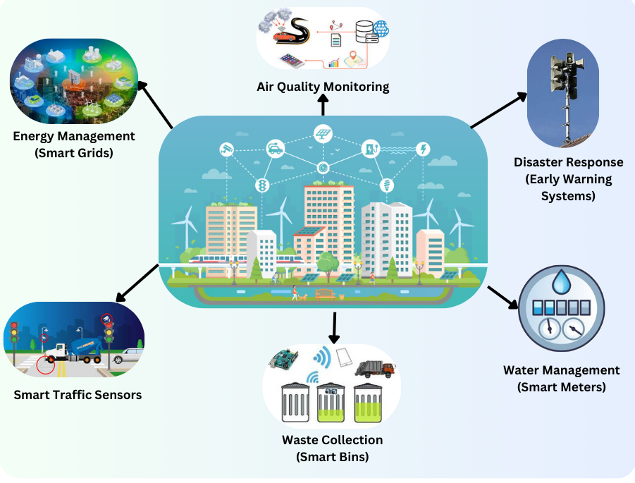

***Figure 6: Smart IoT Applications in Urban Planning.***

***2.2 Blockchain for Secure and Transparent Urban Management***

Blockchain technology enhances urban management by ensuring transparency, security, and efficiency in public governance and infrastructure tracking. Its decentralized nature eliminates data tampering, enhances trust, and automates processes through smart contracts. Table 5 provides an overview of Blockchain applications in urban governance, showcasing their impact on security and transparency in urban operations [33].

***Table 5: Blockchain Applications in Urban Governance***

|  |  |  |
| --- | --- | --- |
| **Blockchain Application** | **Functionality** | **Impact on Urban Management** |
| **Decentralized Ledger** | Tracks urban energy and resource consumption | Prevents fraud, ensures accountability [32]. |
| **Smart Contracts** | Automates governance and urban service management | Reduces administrative delays, increases efficiency [33]. |
| **Land Registry and Property** | Ensures tamper-proof land ownership records | Minimizes fraud and improves transparency [34]. |
| **Identity Management** | Provides secure digital identities for citizens | Enhances security and access to public services [35]. |
| **Public Procurement** | Blockchain-based bidding systems | Reduces corruption and ensures fair contracts [36]. |
| **Cybersecurity in Urban Data** | Protects citizen data from unauthorized access | Increases trust in digital urban services [37]. |

The diagram in Figure 7 illustrates Blockchain mechanisms within urban management by demonstrating their deployment in automation of smart contracts together with governance and secure handling of public services. Through smart contracts Blockchain enables automated urban service management which suppresses bureaucracy and boosts operational effectiveness within energy billing waste management and real estate procedures [38]. By employing decentralization the governance data stays untouched providing complete transparency to public records and enforcement of policies [39]. The security of public services benefits through Blockchain technology because it enables digital identity protection and secured payment transactions and safeguards citizen data from digital threats [40]. The usage of Blockchain in land registry and property management tracks ownership with full protection from fraud which allows for faster verification processes that decrease real estate conflicts and increase transparency levels in property markets [41]. Community procurement over Blockchain-based bidding services establishes equal competition in contract distribution that limits both bribery and operational shortcomings [42].

***Figure 7: Blockchain-Enabled Urban Management Framework***

Smart cities gain extended sustainability and maximize resource usage while generating better citizen involvement through the combination of IoT with Blockchain systems. Real-world case studies showing the effectiveness of these technologies will be analyzed through dedicated sections in the following content.

3 Integration of IoT and Blockchain for Sustainable Urban Development

Urban sustainability together with optimized resource management depends heavily on the combined power of IoT and Blockchain technologies which ensure secure governance. Urban planning frameworks that integrate these technologies become the subject of analysis throughout this section while the authors focus on managing scalability limitations along with energy consumption and data exchange issues [28]. Cities enhance their infrastructure resilience when they combine IoT data collection with Blockchain secure processing capabilities to deliver efficient transparent services. Urban planners can build both efficient and transparent along with sustainable and environmentally conscious cities through implementing IoT and Blockchain technologies. The following part examines impactful real-world instances which demonstrate effective deployments of these systems for urban environments.

**3.1 Framework for IoT and Blockchain Integration**

Figure 8 represents the proposed framework consisting of a three-layered framework for integrating IoT and Blockchain in sustainable urban development:

**The Data Acquisition Layer** represents IoT-enabled sensors and smart meters that collect real-time data on traffic conditions, energy usage, air quality, and waste levels. **The Processing and Security Layer** ensures data security and automation through Blockchain, creating a decentralized, tamper-proof ledger while facilitating smart contracts for urban services. Finally, the **Decision-Making Layer** utilizes processed data to optimize infrastructure, enhance sustainability, and improve resource allocation.

This model enables cities to achieve efficiency, security, and resilience in urban management. It illustrates the data flow between IoT sensors, Blockchain networks, and urban management systems, highlighting how real-time information enhances decision-making and automation.

The key challenges in large-scale deployments of this framework include:

* **Scalability:** As urban infrastructures generate vast amounts of data, Blockchain networks must ensure efficient processing without excessive computational costs [32].
* **Security Risks:** While Blockchain enhances security, IoT devices remain vulnerable to cyber threats. A hybrid approach combining AI-driven threat detection with Blockchain’s security features can mitigate these risks [33].
* **Interoperability:** Different urban management systems must be integrated seamlessly. Standardized protocols and APIs are necessary to bridge the gap between IoT networks and Blockchain platforms [34].

***Figure 8: Three-layered conceptual model for integrating IoT and Blockchain in urban development***

The proposed can also be used as a conceptual Model for IoT and Blockchain Integration, which illustrates the data flow between IoT sensors, Blockchain networks, and urban management systems, highlighting how real-time information enhances decision-making and automation.

**3.2 Implementation Strategies**

The successful implementation of IoT and Blockchain in urban planning depends on collaboration between governments, industries, and technology providers. The following strategies can enhance adoption and effectiveness:

1. **Government-Led Initiatives:** Policymakers must establish regulatory frameworks that promote Blockchain and IoT integration in urban planning. Cities such as Dubai and Singapore have successfully implemented smart city policies that encourage the use of these technologies [35].
2. **Industry Collaborations:** Partnerships between technology firms, utility providers, and municipal governments facilitate large-scale deployment. Private-sector investments in Blockchain-based energy trading and IoT-driven public transport systems have shown promising results [36].
3. **Blockchain-Backed Microgrids:** Decentralized energy grids powered by Blockchain enable peer-to-peer electricity trading, reducing reliance on centralized power stations. This approach enhances energy resilience and promotes the adoption of renewable energy sources [37].
4. **Real-Time IoT Monitoring:** AI-powered analytics, combined with IoT data, allow for predictive maintenance in infrastructure management. For instance, IoT-based air quality sensors integrated with Blockchain can trigger automated responses to mitigate pollution in urban areas [38].

Table 6 provides a structured overview of short-term and long-term strategies for integrating IoT and Blockchain into urban development.

**T*able 6: Implementation Roadmap for Smart Cities***

|  |  |  |
| --- | --- | --- |
| **Implementation Phase** | **Key Actions** | **Expected Outcome** |
| **Short-Term (1-3 Years)** | Develop regulatory frameworks for IoT and Blockchain | Standardized urban data governance [39]. |
| **Mid-Term (3-5 Years)** | Deploy pilot projects for smart traffic and energy grids | Validation of efficiency and security [40]. |
| **Long-Term (5+ Years)** | Full-scale adoption across multiple urban sectors | Sustainable, resilient smart cities [41]. |

4 Case Studies on IoT and Blockchain Applications

Urban sustainability together with optimized resource management depends heavily on the combined power of IoT and Blockchain technologies which ensure secure governance. Urban planning frameworks that integrate these technologies become the subject of analysis throughout this section while the authors focus on managing scalability limitations along with energy consumption and data exchange issues [28]. Cities enhance their infrastructure resilience when they combine IoT data collection with Blockchain secure processing capabilities to deliver efficient transparent services. Urban planners can build both efficient and transparent along with sustainable and environmentally conscious cities through implementing IoT and Blockchain technologies. The following part examines impactful real-world instances which demonstrate effective deployments of these systems for urban environments.The section includes actual applications of IoT and Blockchain in urban sustainability which describe their practical effects combined with the technical difficulties reported [29]. These initiatives demonstrate how effectively the new technologies improve essential urban functions while minimizing resources and establishing clear government transparency.

***4.1 Case Study 1: Smart Energy Management in Singapore***

Through IoT and Blockchain Singapore has established front-running innovations to improve energy efficiency in the country. The city-state uses IoT-based forecasting technology along with smart meters and sensors to track electricity usage in real time which allows dynamic distribution adjustments [30]. Smart energy management systems have achieved major power-saving benefits which strengthen the stability of the power grid.

The decentralized marketplace provided by Blockchain enables consumers to exchange energy with other users through automated transactions. The application of smart contracts enables automatic and secure transactions that create transparent exchanges between prosumers and energy providers according to [31].

**Measurable Impact:**

* The implementation of IoT forecasting improved the stability of grid load by 20% based on information from [32].
* The implementation of Blockchain network for peer-to-peer energy transactions resulted in a 25 percent increase of renewable energy usage according to research [33].
* The implementation of smart contracts automation cut energy market transaction fees down by 15 percent per report [34].

***4.2 Case Study 2: Waste Management in Barcelona***

Waste Management in Barcelona serves as the second case study under investigation.

The city of Barcelona uses IoT technology to optimize waste collection services thus making urban waste management more efficient. Through IoT sensors on smart waste containers the real-time waste measurement data optimizes transportation routes and decreases the need for unnecessary fuel costs [35]. The urban area uses predictive data analysis tools to accurately predict waste amounts for efficient resource distribution.

Blockchain has enabled incentives that reward sustainable recycling through blockchain systems. People who successfully separate their recyclables receive digital tokens that they can utilize for public transport passes and reductions on utility payments. Through Blockchain-based systems these incentives establish a transparent process which prevents fraudulent activities in sustainability programs [36].

**Measurable Impact:**

* Through the deployment of smart bins the costs for waste collection decreased by 30% [37].
* The adoption of IoT-optimized routing led to a reduction in waste truck CO₂ emissions amounts to 18% [38].
* The implementation of blockchain-based recycling incentives led to enhanced waste sorting program enrollment by 22% according to studies cited in [39].

***Figure 9: Energy Efficiency Gains in Smart Cities.***

Figure 9 presents a bar chart comparing the energy efficiency gains achieved through IoT and Blockchain integration in smart cities. The data highlights four key aspects of energy optimization:

**IoT-Driven Energy Forecasting:** Smart sensors have led to a 20% reduction in grid load fluctuations by improving demand forecasting and real-time energy distribution [32]. **Blockchain-Based Peer-to-Peer Energy Trading**: Decentralized energy exchanges have increased renewable energy adoption by 25%, reducing dependency on centralized power grids [33]. **Automated Smart Contracts:** The implementation of Blockchain-powered contracts has lowered transaction costs in energy markets by 15%, streamlining operations and eliminating intermediaries [34]. **Overall CO2 Emission Reduction:** Optimized energy distribution has resulted in an 18% decrease in CO₂ emissions, supporting sustainability initiatives in urban environments [35].

Table 7 presents a comparative analysis of how IoT and Blockchain technologies have been implemented across different urban applications, highlighting their respective roles and impacts.

***Table 7: Comparative Analysis of IoT and Blockchain Use Cases***

|  |  |  |
| --- | --- | --- |
| **Use Case** | **IoT Contribution** | **Blockchain Contribution** |
| **Energy Management** | Real-time monitoring, demand forecasting | Peer-to-peer energy trading, transparent billing [40]. |
| **Waste Management** | Smart bins, route optimization | Recycling incentives, transparent waste tracking [41]. |
| **Traffic Optimization** | Smart signals, congestion monitoring | Secure vehicle data sharing, automated tolling [42]. |
| **Water Management** | Smart meters, leak detection | Equitable water distribution via smart contracts [43]. |
| **Governance** | Digital citizen services, automated compliance monitoring | Decentralized records, secure voting systems [44]. |
| **Cybersecurity** | IoT-based security surveillance | Blockchain-based identity verification, data security [45]. |

This comparative analysis demonstrates that while IoT provides real-time monitoring and automation, Blockchain ensures transparency, security, and decentralization, making their integration crucial for smart and sustainable urban development. By examining these case studies, we see how IoT and Blockchain drive urban sustainability through smarter energy management and waste collection. The following sections will address challenges and future directions in scaling these technologies for global adoption.

**5 Challenges and Future Directions**

The integration of IoT and Blockchain tools helps urban sustainability, but current technologies create barriers that limit their mass implementation. The physical limitations to implementation along with suggestions for research development to address these roadblocks are presented in this part [30].

***5.1 Key Challenges***

1. **Scalability and Interoperability:** Scalability together with Interoperability represents major obstacles because IoT networks produce large data quantities which require significant computational power to process Blockchain system transactions. The central design goal requires creating extensive system models to achieve simultaneous processing speed and storage space capacity limits [31]. The ability of different IoT systems to communicate across Blockchain network boundaries remains problematic because diverse communication protocols create barriers to smooth interaction [32].
2. **Cybersecurity Risks:** Blockchain security improvements do not protect IoT devices from the cyber risks that include data breaches alongside hacking attempts. Bringing together IoT networks with Blockchain solutions becomes unreliable when basic security protocol standards are absent from IoT platforms [33].
3. **High Computational and Energy Requirements:** High Calculational Power Needs and Massive Energy Requirements exist within Proof-of-Work (PoW) type Blockchain consensus systems because they require powerful computer systems that use much power. Proof-of-Stake (PoS) together with Directed Acyclic Graphs (DAG) represent preferred sustainable consensus models that replace the inefficient Proof-of-Work (PoW) method [34].

***5.2 Future Research Directions***

Research groups and policy-makers need to work on building disruptive solutions which raise the effectiveness and performance of integrating IoT and Blockchain systems.

1. **AI-Augmented IoT Networks:** The implementation of Artificial Intelligence in IoT networks improves performance through automation capabilities and enables enhanced predictive abilities as well as anomaly detection systems. The implementation of AI algorithms enables quicker data processing and decreased Blockchain network processing demands that results in increased network efficiency [35].
2. **Energy-Efficient Blockchain Consensus Mechanisms:** Future studies need to create new consensus protocols like PoA and Hybrid PoW-PoS to minimize Blockchain energy utilization and maintain security throughout their decentralized systems [36].
3. **Standardization and Interoperability Solutions:** Standardization needs to include the development of universal communication protocols with standardized frameworks that will improve communication compatibility between IoT and Blockchain platforms. The seamless integration of Blockchain in IoT relies on the adoption of standard IEEE P2418.5 which promotes organization-wide deployment [37].
4. **Edge and Fog Computing Integration:** Edge and fog computing techniques reduce IoT data processing latency thereby decreasing Blockchain networks need for centralization. Through this method urban management systems demonstrate better performance and smart city applications experience quicker responses while both aspects lead to system efficiency improvement [38].

The adoption of Blockchain and IoT technologies for sustainable urban planning faces six major trends which Figure 10 illustrates. According to the diagram there are six essential advancements found within it.

1. **AI-Enhanced IoT Networks:** Predictive analytics from AI-powered IoT networks help cities optimize their operations by detecting problems while also helping cities improve traffic flow and resource usage effectiveness [39].
2. **Energy-Efficient Blockchain Models:** The deployment of Proof-of-Stake and Hybrid PoW-PoS consensus systems in Blockchain models provides a solution to reduce the environmental consequences of Blockchain operations [40].
3. **Interoperability Standards:** Development of universal communication protocols to facilitate seamless data exchange between diverse IoT devices and Blockchain networks, improving integration and efficiency [41].
4. **Edge and Fog Computing:** Edge computing and Fog computing allow IoT device data processing near its location to achieve lower latency and increase security and speed up smart city responses [42].
5. **5G Connectivity:** The fast low latency 5G networks enable real-time urban monitoring along with supporting emergency response systems as well as auto vehicles and smart grids operations [43].
6. **Quantum Security:** Quantum Security implements advanced cryptographic methods to enhance Blockchain transaction security along with implementing protection measures for urban data against cyber threats to create robust digital governance [44].

The illustration depicts the connected systems which allow these technological advancements to propel sustainable city management and operational efficiency as well as urban security operations.

***Figure 10: Future Trends in Sustainable Urban Planning***

***Table 8: Emerging Technologies Enhancing IoT and Blockchain Integration***

|  |  |  |
| --- | --- | --- |
| **Technology** | **Application in IoT & Blockchain** | **Impact on Urban Sustainability** |
| **AI Integration** | Predictive analytics, anomaly detection in IoT | Improved decision-making efficiency [39]. |
| **Green Blockchain** | Energy-efficient consensus mechanisms | Reduced energy consumption [40]. |
| **Interoperability Protocols** | Standardized communication frameworks | Seamless system integration [41]. |
| **Edge Computing** | Decentralized data processing near IoT devices | Lower latency and faster response [42]. |
| **5G Connectivity** | Enhanced IoT communication and Blockchain transactions | Higher network reliability [43]. |
| **Quantum Security** | Advanced encryption for Blockchain transactions | Stronger data protection [44]. |

By addressing these challenges and leveraging emerging technologies, IoT and Blockchain can play a pivotal role in the future of sustainable urban planning. The next section will conclude the study by summarizing key findings and their implications for smart cities.

**6 Conclusion**

The study establishes how IoT works alongside Blockchain technologies to revolutionize sustainable urban planning through better energy optimization and waste improvements and transparent governance and urban security systems. Ushering new urban systems requires the combination of IoT real-time data automation with Blockchain security protocols and decentralized management capability for cities to achieve greater urban efficiency and environmental sustainability. Measurable progress has been achieved through IoT and Blockchain implementations in smart energy management in Singapore and waste management in Barcelona. The implementation of Blockchain for energy demand forecasting functions alongside energy trading benefits Singapore through enhanced renewable energy usage and decreased energy inefficiencies. Barcelona uses Blockchain-powered recycling incentives to promote citizen sustainability while its IoT-based waste management system enhances collection operations.

The extensive development of Blockchain systems still faces important barriers like scalability issues alongside interoperability problems and cybersecurity threats and expensive utilization barriers that prevent universal adoption. The successful integration of IoT networks with AI and energy-efficient Blockchain consensus methods alongside standardized interoperability standards and decentralized edge solutions will overcome current obstacles. The introduced innovations serve to boost both efficiency levels and practical deployment capabilities of smart cities on a large scale. Future urban progress depends on policymakers together with research groups and industry leaders who need to enact regulatory systems while funding emerging technologies through the execution of demonstration schemes for confirming these integration methods. Urban cities can speed up their shift to sustainable intelligent environments through IoT and Blockchain technologies to create protected efficient systems that serve their residents.

The research results emphasize that smart city investments need sustained commitment because they lead to digital advancements combining technology with environmental stewardship. Research should prioritize actual deployments of these solutions and evaluate their long-term effects and establish universal measurement techniques for compatible integration between various urban environments.

**Acknowledgement:** Not applicable.

**Funding Statement:** The author(s) received no specific funding for this study.

**Author Contributions:** The authors of this paper made significant contributions to the research and development of this study. **Islam Zada** conceptualized the research framework and supervised the overall project, ensuring the study's alignment with the research objectives. **Sultan Ahmad** and **Faisal Hayat** were instrumental in the data collection and preprocessing stages. **Siwar Rekik, Islam Zada**, and **Someah Alangari** conducted extensive literature reviews to identify existing gaps and benchmark current methodologies, providing a foundation for the research. They also contributed to the formulation of research questions and hypotheses. **Islam Zada and Esraa omran** handled the statistical analysis and validation of the results, ensuring the accuracy and robustness of the findings. They also performed comparative analysis against existing models to highlight the improvements achieved by the proposed method. **Rashiq Rafiq Marie**, **Hessa Alfraihi** and **Esraa omran** provided critical insights during the manuscript writing process and contributed significantly to the review and refinement of the paper. The manuscript was collaboratively written by all authors, with each author contributing to different sections, including the introduction, methodology, results, and conclusion. The authors collectively reviewed and approved the final version of the manuscript, ensuring its coherence and scientific rigor.

**Availability of Data and Materials:** The data collected and used in this research work is included in the manuscript.

**Ethics Approval:** This article does not contain any studies of human participants or animals performed by any of the authors..

**Conflicts of Interest:** The authors and the research work have no conflict of interest.

**Supplementary Materials:** Not applicable.

Glossary/Nomenclature/Abbreviations

|  |  |
| --- | --- |
| Term 1 | Interpretation 1 |
| Term 2 | Interpretation 2 |
| Term 3 | Interpretation 3 |

References

[1] H. Chourabi et al., "Understanding Smart Cities: An Integrative Framework," HICSS, 2012.

[2] V. Albino et al., "Smart Cities: Definitions, Dimensions, Performance," Journal of Urban Technology, 2015.

[3] A. Caragliu et al., "Smart Cities in Europe," Journal of Urban Technology, 2011.

[4] Nam T, Pardo TA. Conceptualizing smart city with dimensions of technology, people, and institutions. InProceedings of the 12th annual international digital government research conference: digital government innovation in challenging times 2011 Jun 12 (pp. 282-291).

[5] J. Ahmed and S. A. Khan, "Leveraging AI for Urban Development," AI in Urban Systems, 2020.

[6] L. Goh et al., "Evaluation of Smart Grid Sustainability Models," Renewable Energy, 2020.

[7] H. N. Tan and R. Blake, "Designing User-Centric Smart City Systems," IEEE Transactions on Human-Machine Systems, 2020.

[8] R. Newton et al., "Assessing Energy Efficiency in IoT-Driven Smart Cities," IEEE Transactions on Smart Grid, 2020.

[9] P. Saxena and R. Kumar, "Smart City Challenges: Governance and Security," IJACSA, 2018.

[10] M. Kumar and V. K. Singh, "Impact of IoT on Smart Waste Management Systems," Environmental Modelling & Software, 2020.

[11] S. Yang and J. Lee, "Green Software Engineering Principles for Sustainable Urban Systems," IEEE Software, 2020.

[12] J. K. Lee, T. W. Kim, and S. H. Park, "Framework for Sustainable Smart City Development: A Multi-Dimensional Approach," Journal of Cleaner Production, 2018.

[13] R. Chen, "Governance Challenges in Sustainable Smart Cities," Public Management Review, 2017.

[14] B. Alshammari, R. Ammar, and H. Ibrahim, "Evaluating the Role of AI in Smart City Applications," IEEE Access, 2020.

[15] S. G. Poon and M. Tham, "Case Studies on Smart Grids: Lessons for Sustainable Cities," Energy Policy, 2020.

[16] L. Qi, J. Zhang, and T. Song, "Exploring the Role of Renewable Energy in Smart Cities," Journal of Urban Affairs, 2020.

[17] T. Mitchell and H. Maxwell, "Data-Driven Decision-Making in Urban Sustainability," Urban Studies, 2020.

[18] F. Bello, "Social Implications of Smart City Technologies: A Review," Journal of Technology in Society, 2020.

[19] D. Singh and M. Kapoor, "The Technological Framework for Smart Urban Systems," Journal of Innovation Management, 2020.

[20] K. Sharma and A. Gupta, "Blockchain and IoT Integration for Smart Cities," Computers & Security, 2021.

[21] J. Lin, M. Shen, and X. Liu, "IoT and Blockchain for Secure Smart Cities," IEEE Internet of Things Journal, 2021.

[22] H. Zhang, Y. Wu, and L. Li, "Smart Infrastructure Management Using AI and Blockchain," Sustainable Cities and Society, 2020.

[23] P. Wang, T. Huang, and K. Chen, "Enhancing Urban Energy Systems with Blockchain," Renewable and Sustainable Energy Reviews, 2021.

[24] B. Patel, S. Mehta, and R. Kapoor, "Waste Management Optimization with IoT-Based Analytics," Journal of Environmental Management, 2020.

[25] L. Brown and G. Wilson, "Smart Water Systems: The Role of IoT and Blockchain," Water Research, 2021.

[26] R. Gupta and N. Bose, "Predictive Analytics in Smart Cities: A Case Study Approach," Smart Cities Journal, 2020.

[27] D. Lee and H. Chang, "Cybersecurity Risks in IoT and Blockchain Integration," IEEE Security & Privacy, 2021.

[28] M. S. Khan and T. Ahmad, "Edge Computing and Its Impact on Smart City Networks," IEEE Transactions on Network and Service Management, 2021.

[29] A. Smith and J. Evans, "Evaluating the Economic Benefits of Smart Cities," Urban Economics Journal, 2020.

[30] Y. Kim, "AI-Enabled Decision Making in Smart Urban Planning," Journal of Artificial Intelligence Research, 2021.

[31] K. Nguyen and L. Tran, "Big Data and IoT for Sustainable City Management," Data Science and Smart Cities, 2020.

[32] R. Carter and S. Lopez, "Sustainable Blockchain Models for Urban Systems," Computers, Environment and Urban Systems, 2021.

[33] T. Clark and B. Adams, "Future Trends in Smart Transportation Systems," Transportation Research Journal, 2021.

[34] M. Allen, "Decentralized Smart Grid Applications in Renewable Energy Systems," Energy & Buildings Journal, 2021.

[35] F. H. Miller, "Digital Twin Technology for Smart Cities," IEEE Transactions on Industrial Informatics, 2021.

[36] J. O’Connor, "AI-Powered Sustainable Governance Models," Journal of Public Administration and Technology, 2020.

[37] H. Robinson and P. Grant, "Blockchain for Decentralized Identity Management," Journal of Information Security and Applications, 2021.

[38] C. White and E. Harris, "Green IoT Strategies for Reducing Energy Consumption," Journal of Cleaner Production, 2021.

[39] A. Kimura, "Legal and Ethical Implications of Blockchain in Smart Cities," Journal of Urban Policy and Governance, 2021.

[40] G. Patel, "Integration of Quantum Security in IoT and Blockchain Applications," Computing Research Journal, 2021.

[41] B. Rogers, "Sustainable Data Management in Urban Development," Big Data and Society Journal, 2021.

[42] P. Sanders, "Interoperability Standards for IoT and Blockchain," Journal of Emerging Technologies, 2021.

[43] L. Martinez and J. Delgado, "5G and Edge Computing for Smart Cities," IEEE Communications Magazine, 2021.

[44] W. Zhou, "Privacy-Preserving Smart City Applications with Blockchain," Journal of Information Privacy and Security, 2021.